PROJECT DESIGN PHASE-II
DATA FLOW DIAGRAM & USER STORIES
Date
Team ID | SWTID-2026-3317 _______________________
Project Name | AI FAQ Assistant
Maximum Marks | 4 Marks

1. Data Flow Diagram
The DFD shows how questions, authentication information, FAQ data and responses flow through the AI FAQ Assistant. Users interact with the system, the system retrieves FAQ information, processes the query and returns an answer. Administrators manage FAQ records.
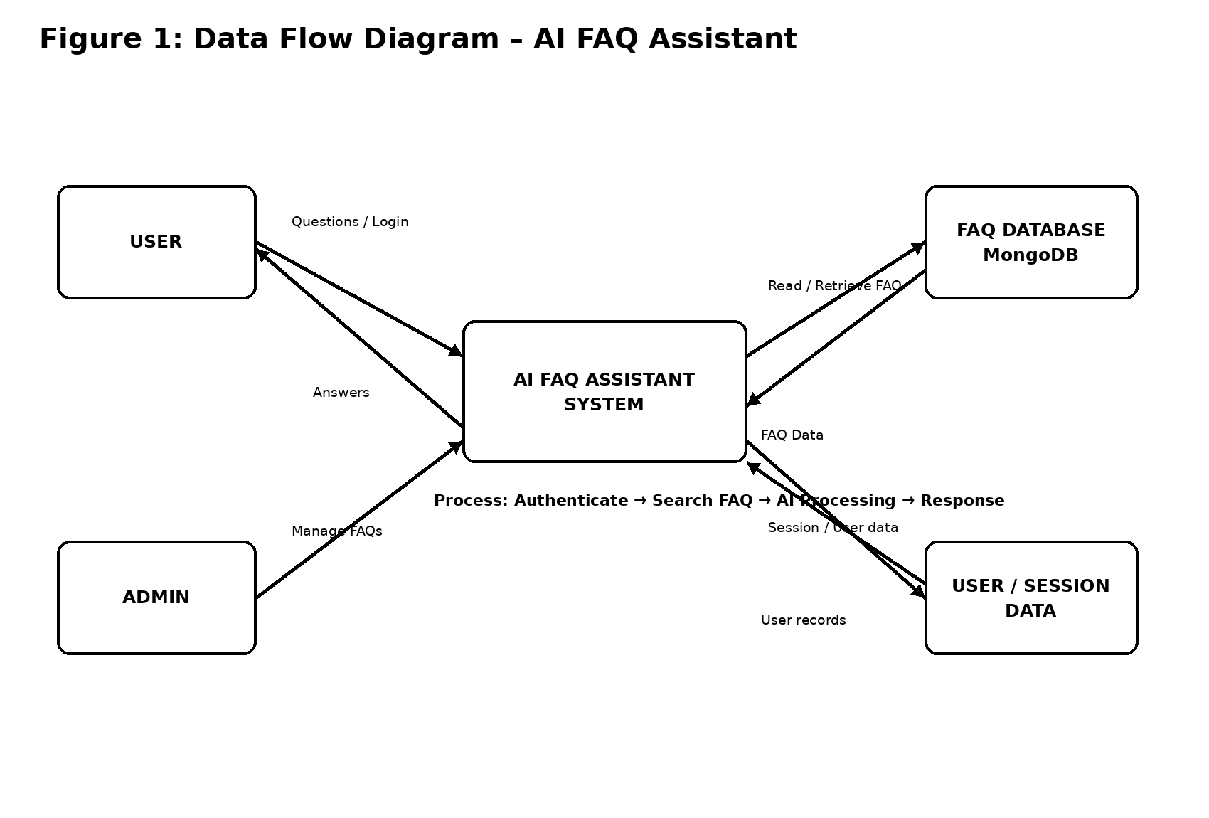
Figure 1: Data Flow Diagram of the AI FAQ Assistant

2. User Stories
The following user stories cover the main requirements of the AI FAQ Assistant for customers, support staff and administrators.
User Type | Functional Requirement (Epic) | User Story Number | User Story / Task | Acceptance Criteria | Priority | Release
Customer (Web user) | Registration | USN-1 | As a user, I can register using my email and password. | Account is created and user can access the dashboard. | High | Sprint-1
Customer (Web user) | Login | USN-2 | As a user, I can log in using email and password. | Valid credentials allow access; invalid credentials show an error. | High | Sprint-1
Customer (Web user) | FAQ / Dashboard | USN-3 | As a user, I can view frequently asked questions and answers. | FAQ list loads correctly and answers are readable. | High | Sprint-1
Customer (Web user) | AI Assistant | USN-4 | As a user, I can ask a question in natural language. | Question is submitted and a relevant response is displayed. | High | Sprint-2
Customer (Web user) | AI Assistant | USN-5 | As a user, I can receive a helpful response for an unknown question. | System provides a suitable fallback message when no relevant FAQ is found. | Medium | Sprint-2
Customer (Web user) | Session | USN-6 | As a user, I can log out of the application. | Session ends and user is returned to the login page. | Medium | Sprint-2
Customer Care Executive | FAQ Support | USN-7 | As a support executive, I can search FAQs to answer customer queries. | Relevant FAQ records can be searched and viewed. | High | Sprint-2
Customer Care Executive | Feedback | USN-8 | As a support executive, I can identify unanswered or unclear questions. | Unresolved questions can be recorded for FAQ improvement. | Medium | Sprint-3
Administrator | FAQ Management | USN-9 | As an admin, I can add new FAQs. | New FAQ question and answer are validated and stored. | High | Sprint-2
Administrator | FAQ Management | USN-10 | As an admin, I can update existing FAQs. | Updated FAQ data is saved and visible to users. | High | Sprint-2
Administrator | FAQ Management | USN-11 | As an admin, I can delete outdated FAQs. | Selected FAQ is removed after confirmation. | Medium | Sprint-3
Administrator | User Management | USN-12 | As an admin, I can manage authorized users and roles. | User/role information can be viewed and managed securely. | Medium | Sprint-3
Administrator | Monitoring | USN-13 | As an admin, I can monitor FAQ usage and system feedback. | Basic usage/feedback information is available for improvement. | Low | Sprint-3

